
Restservice Selfhelpgroup Design And Release v1.0

changes | version | author | date
Design of the document | v1.0 | Annika Beißler | 27.01.2021

Table Of Contents
1 Release Strategy 2
2 Compatibility 2
3 Software Design 3
4 Software Changes 7

Release Strategy

Branching With Git
Restservice Selfhelpgroup is a REST service. It is developed on git in node.js and than hosted on a server. The branching strategie on git hub will be:
The development takes place on the branch development. Than the version v1.0 will be build. Tests will be done with the software on the branch release-v1.0. If the software passes the tests it will be deployed on a server. Than there will be the finale tests. If this requires bug fixes the bug fixes will take place on the development branch. They will be cherry picked and moved to the branch release-v1. 0 until the Software passing the tests on the server. The final version gets taken. Now all changes are on the release branch as well as on the develop branch, because of the cherrypickig method and the release branch can be deleted.

Test Documents

name document | documented | date
 | Software tests done with developed Software.
 | Software tests done with server.

Compatibility
When this REST service is released, the Restservice Selfhelpgroup will run on a server. Here are listings of the Software versions that are recommended for Restservice Selfhelpgroup v1.0.

Installed Versions Developement

Component | Comment | Installed Version
node.js |  | 15.6.0-x64
npm | Is a part of node, but needs to be updated | 7.4.3

Installed Versions Server

Component | Comment | Installed Version
node.js
npm

Software Design

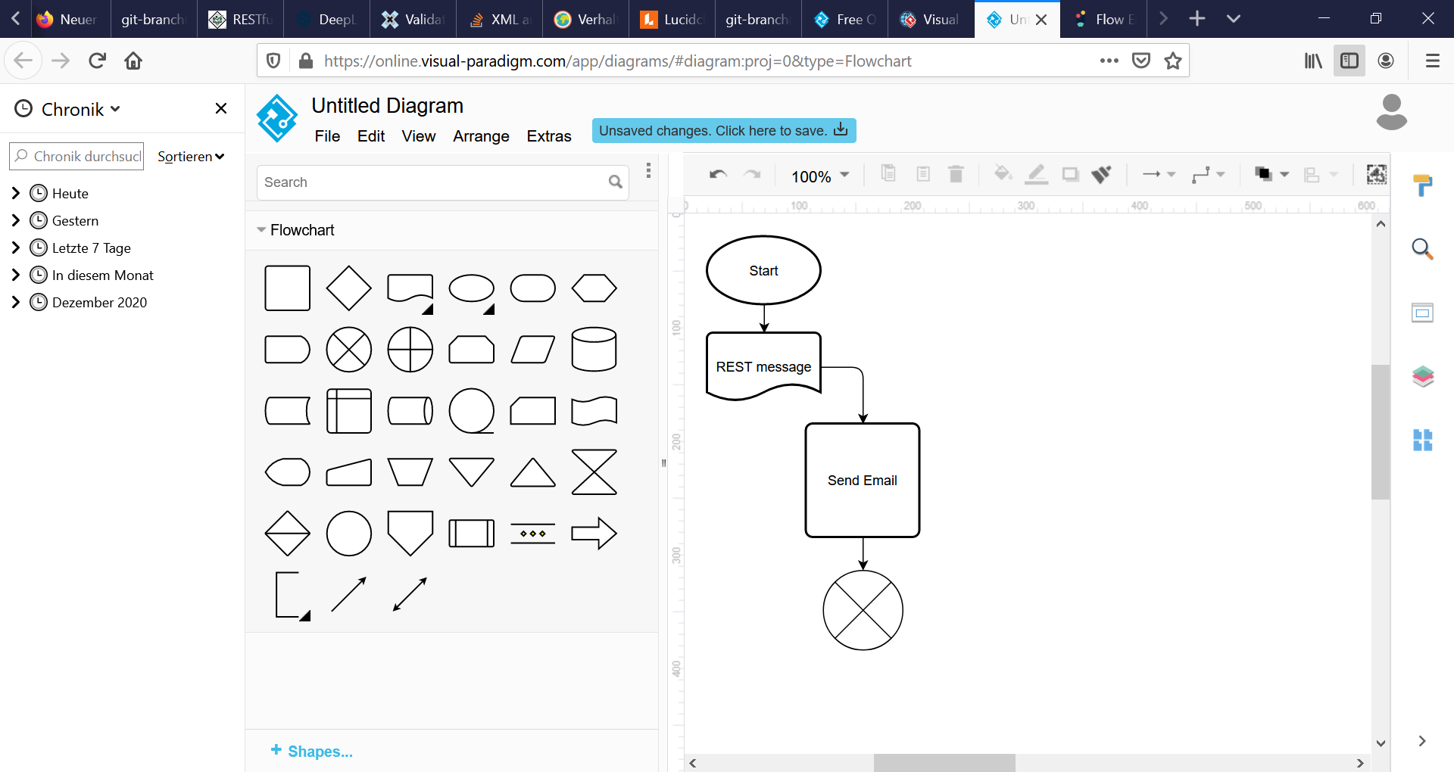
Flowchart

Userstory
There is an observer. People on "brainspace" share experiences. That is, people are connected to a brain machine interface. Several persons are neurologically connected with a technology. The brain is stimulated or the different brain regions get additional signals. The person who experiences the brain machine interface has more experiences than the experiences he has through the experience of his environment. Ideally, the person knows about this technology, otherwise he would find explanations such as daydream or psychological disorder for that experienced. The technology can be used in such a way that only now and then memories of the experienced are awakened. The observer can get a picture of the psychological strategies and the psychological constitution of the person. It can be reported to him what the persons have experienced with the dreams and the realities of others. Since some people have been exposed to bad experiences and also some psychological strategy resembles a behavioral disorder, the need for psychotherapy is clear. The observer then consults with each other, and from a client, the required information is sent in order to send an email that informs the person in question and recommends him/her to seek a therapist.

REST-Message
Here is an example of a bench message to the rest server. This is how the body of the rest message should look like. Version 1.0 will only support the experience type fainting and death. Only depressive or sadistic can be sent as personality damage. Two languages are supported: english and german.
<?xml version="1.0" encoding="UTF-8"?>
<body>
<surname>Mustermann</surname>
<name >Max</name>
<salutation>Herr</salutation>
<language> german</language>
<email>
max.mustermann@mail.com
</email>
<beschadet>
<personalityDamage></personalityDamage>
<experience ExperienceType="fainting">
<experienceDescription>
Sie haben erlebt, wie sie im Körper einer anderen Person sexuell missbraucht wurden.
</experienceDescription>
</experience >
</beschadet>
<coment>
Wir finden es toll wie du mit trauer umgehst. Möchtest du bewusst an philosophischen Runden teilnehmen?
</coment>
</body>

If the reason for sending the message to the RESTservice is that the person has a personality immage the ‚beschadet‘-part might look like this:

<beschadet>
<personalityDamage>depressive</personalityDamage>
<experience></experience>
</beschadet>

Example Email-Nachricht
Here is an example of a bench message to the person, matching the rest message above. The example is in German, because the language is adjustable. All information taken from the rest message is marked.
Guten Tag Herr Max Mustermann,
Diese Empfehlung für sie von der Selbsthilfegruppe für Brain Machine Interfaces wurde automatisch erstellt. Wir freuen uns darüber, wenn sie Kontakt aufnehmen. Wir sind uns sicher dass sie mit dieser Technologie in Berührung gekommen sind. Mit dieser Technologie können mehrere Menschen Neurologisch verbunden werden. Das Hirn wird stimuliert oder die verschiedenen Hirnregionen bekommen zusätzliche Signale. Es erweitert also ihre Sinne. Es ist wie eine Art künstliche Telepathie , aber es ist auch möglich dass die Signale ihres zentralen Nervensystems so getauscht werden, dass sie als eine andere Person deren Realität erleben oder aber auch zusätzlich Sinneseindrücke aus einer anderen Realität mitnehmen. Dann kann es auch sein, dass sie in ihrem Leben sich nicht richtig ihren aufgaben widmen konnten und Erinnerungen haben, die sie sich nicht richtig erklären können.
Wir schreiben sie allerdings an um ihnen einen Ratschlag zu geben, weil sie vielleicht für sich selbst unerklärliche Emotionszustände erleben.
If the mail would have been requested in english, the text would be:
Hello Mr. Max Mustermann,
This recommendation for you from the Brain Machine Interfaces support group was created automatically. We will be glad if you contact us. We are sure that you have been in contact with this technology. With this technology several people can be neurologically connected. The brain is stimulated or the different brain regions get additional signals. So it enhances their senses. It is like a kind of artificial telepathy, but it is also possible that the signals of their central nervous system are exchanged in such a way that they experience as another person their reality or also take additional sensory impressions from another reality. In this case it is also possible that you have not been able to dedicate yourself properly to your tasks in life and that you have memories that you cannot explain properly.
However, we write to them to give them advice because they may be experiencing emotional states that are inexplicable to themselves.
This text is part of the email because 'depressive' was given as the personality damage:
Mit dieser Technologie können wir sowohl emotionale Zustände, sowie soziale Strategien von Anderen beurteilen. Teilweise werden emotionale Logiken unabhängig vom Individuum genutzt, die ist ungewohnt für Menschen. Dabei fallen uns auch für den Menschen unfunktionelle emotionale Strategien sowie unangenehme Grundstimmungen auf. Sie sind als eher depressiv aufgefallen.
If the mail would have been requested in english, the text would be:
With this technology we can assess emotional states, as well as social strategies of others. In some cases, emotional logics are also used in a way, that is unusually, independent of the individual. We also notice emotional strategies that are unfunctional for humans as well as unpleasant basic moods. They are noticed as rather depressive.
This text is part of the email because 'sadist' was specified as the personality damage:
Mit dieser Technologie können wir sowohl emotionale Zustände, sowie soziale Strategien von Anderen beurteilen. Teilweise werden emotionale Logiken unabhängig vom Individuum genutzt, die ist ungewohnt für Menschen. Sie haben die Motivation anderen zu schaden. Es kann sein dass sie erstmals nicht darunter leiden. Mitgefühl hat den Nachteil das man mit seiner Umwelt mitleidet, trotzdem möchte ich ihnen raten sich eine Therapie wegen der vermuteten destruktiven Persönlichkeitsstörung zu suchen. Die Vorteile für sie wären ein glücklicheres eben und vielleicht mehr persönliche Nähe zu anderen Menschen.
If the mail would have been requested in english, the text would be:
With this technology we can assess emotional states as well as social strategies of others. In part, emotional logics are used independently of the individual, which is unusual for people. They have the motivation to harm others. It may be that they do not suffer at first. Compassion has the disadvantage that you suffer with your environment, nevertheless I would like to advise you to seek therapy for the suspected destructive personality disorder. The advantages for you would be a happier life and perhaps more personal closeness to other people.
This text is part of the email because an experience was given:
Wenn man im Leben mit besonders schlimmen Erlebnissen konfrontiert wurde kann es sein, dass man psychologische Betreuung braucht. Auch wenn dieses Thema in unserer Gesellschaft oft ein Tabuthema ist, wir denken nicht, dass sie verrückt sind, sondern dass sie sich einfach professionelle Hilfe für die Emotionale Verarbeitung folgendes Erlebnisses suchen sollten:
Sie haben erlebt, wie sie im Körper einer anderen Person sexuell missbraucht wurden.

If the mail would have been requested in english, the text would be:
If you have been confronted with particularly bad experiences in your life, you may need psychological care. Even though this topic is often a taboo subject in our society, we do not think that you are crazy, but that you should simply seek professional help for the emotional processing of the following experience:
They have experienced being sexually abused in the body of another person.

Since 'fainting' was specified as the type of experience, the following text is added to the email:
Dieses Erlebnis ist besonders Schlimm für die Psyche da man eine Situation erlebt, die für einen selbst schlecht ist, trotzdem konnten sie dieser Situation nicht entfliehen. Mehrere Situationen dieser Art und dass erleben sie vielleicht führen zu Depression. Bei einer Verhaltenstherapie erlernen sie die richtigen Strategien.

If the mail would have been requested in english, the text would be:
This experience is especially bad for the psyche because you experience a situation that is bad for you, yet you could not escape this situation. Several situations of this kind and that they experience may lead to depression. In a behavioral therapy they learn the right strategies.

If Death is specified as the event type, the following text will be included in the email:
Jeder Mensch muss irgendwann sterben. Folglich müssen wir uns auch damit auseinandersetzen. Diese Email ist hilfreich, dass ihnen jemand glaubt. Es liegt an ihnen zu entscheiden ob sie ein Gespräch in ihrem Umfeld mit einem Geistlichen oder mit einem Therapeuten suchen. Reden sie darüber. Es wird ihnen gut tun.

If the mail would have been requested in english, the text would be:
Everyone has to die at some point. Consequently, we also have to deal with it. This email is helpful that someone believes them. It is up to you to decide whether you want to talk to a clergyman or a therapist in your environment. Talk about it, it will do you good.

Then, of course, there is the greeting in the email. In German:
mit freundlichen Grüßen
Selbsthilfegruppe Brain Machine Interfaces

and in english:
with kind regards
Selfhelpgroup Brain Machine Interfaces

Software Changes
Since this is the releasedocument for Softwareversion 1.0 there are no softwarechanges messured here.

